**Test cases and bug reporting-Task 5**

Project management tool JIRA

Q1. Write as many test cases as you can for a given scenario using Excel sheet. The Excel sheet should include the following columns:

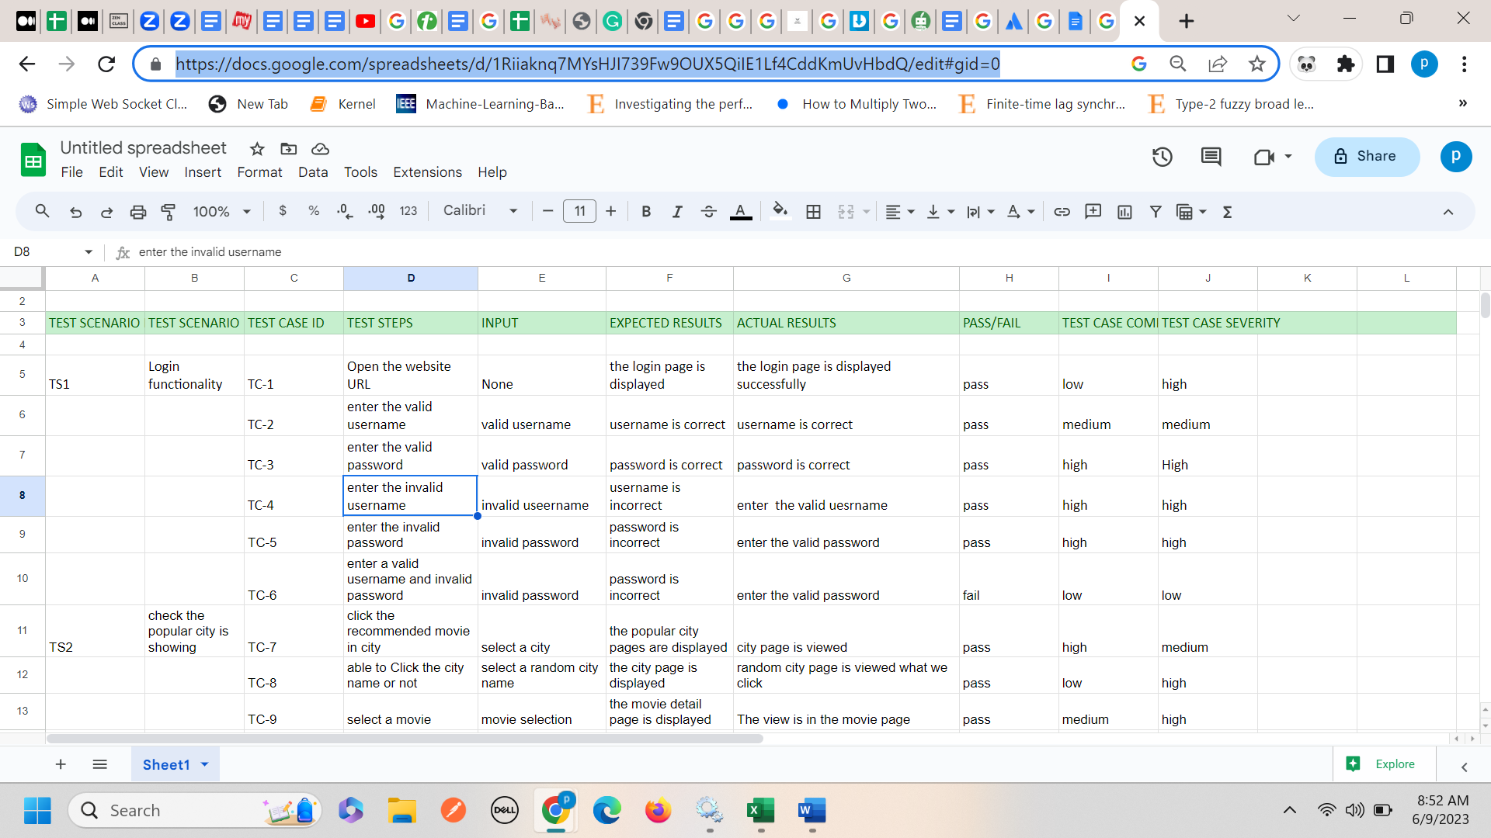

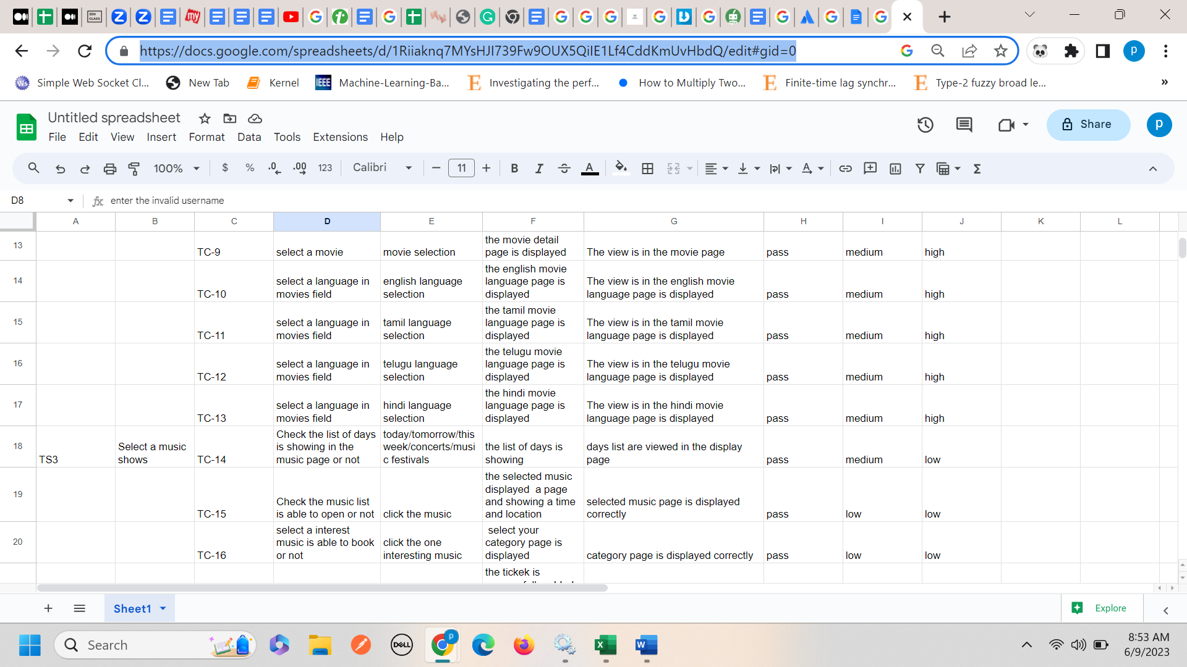

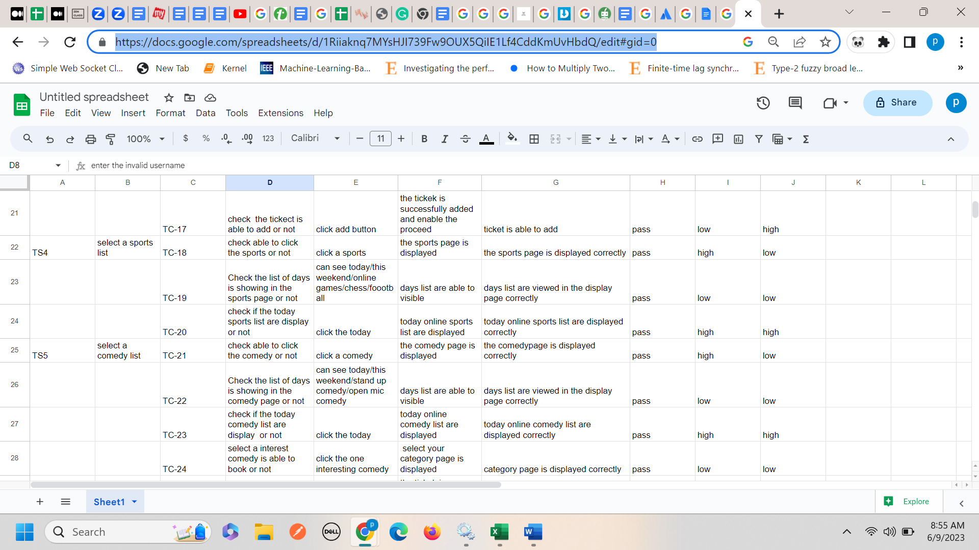

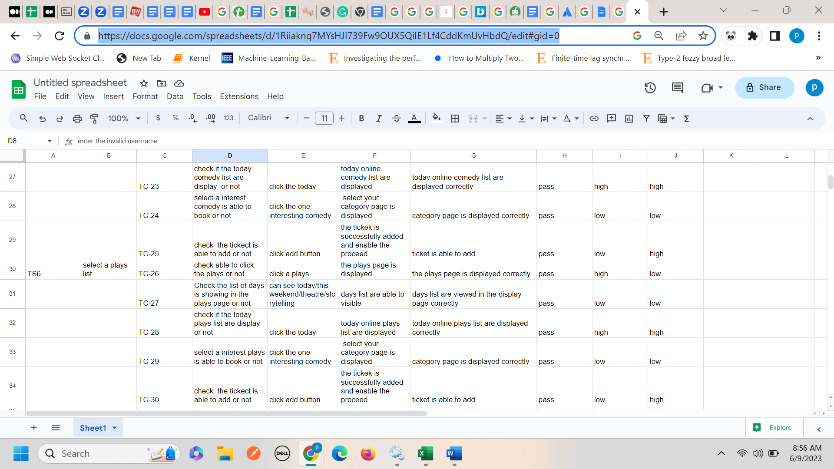

Link for bookmyshow testcase in google sheet.

<https://docs.google.com/spreadsheets/d/1Riiaknq7MYsHJI739Fw9OUX5QiIE1Lf4CddKmUvHbdQ/edit#gid=0>

**JIRA TOOL:**

1. **Create a test case using jira tool:**

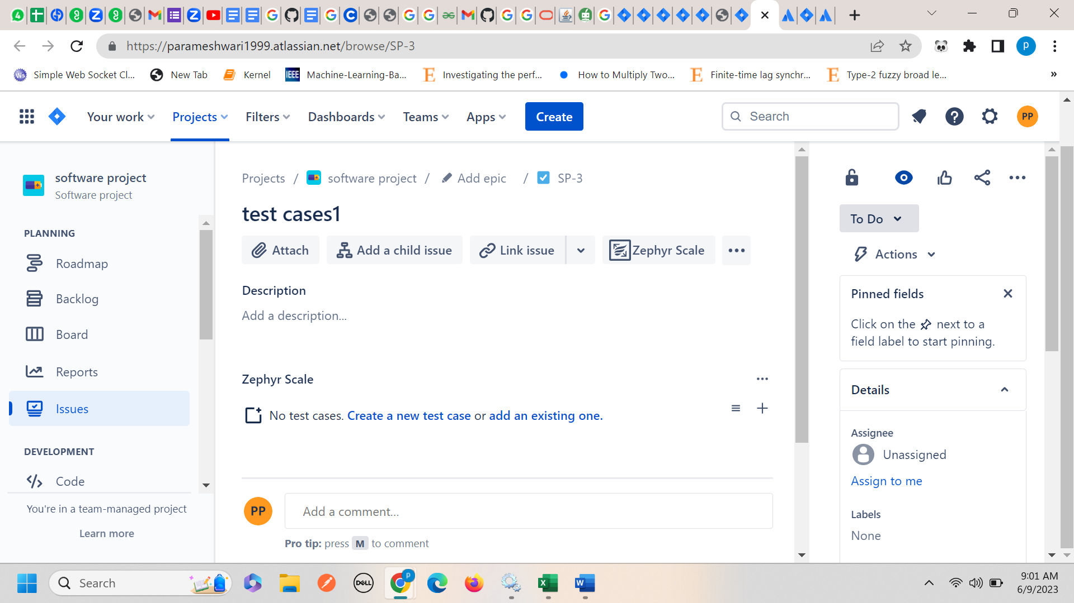

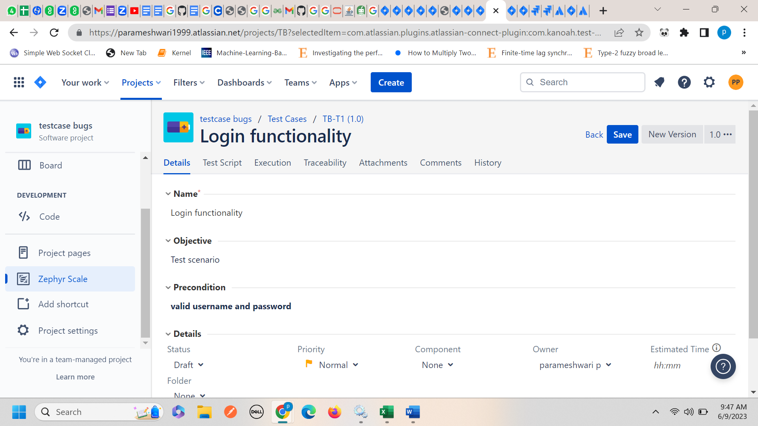

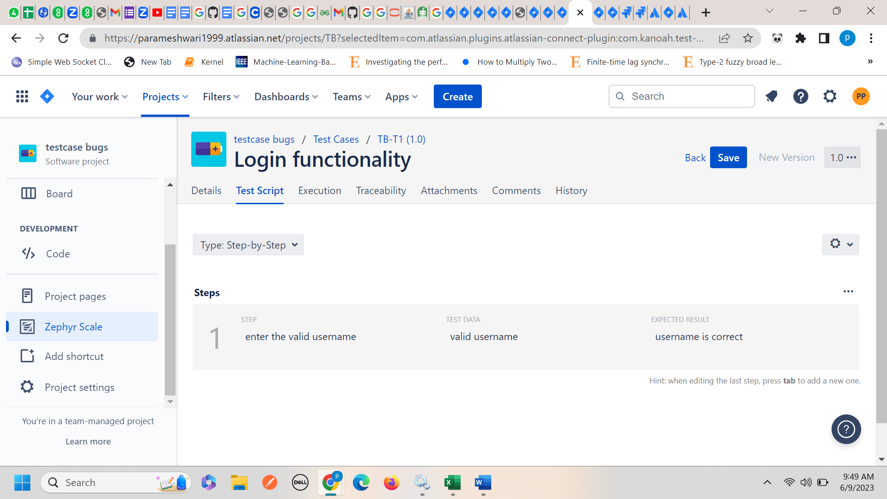

**Q2. Write the key points on Test Scenario, Test Case, Test Strategy and Plan, Test Summary:**

**Test Scenarios:**

1. Testing the functionality of software application.
2. Tested overview of project and test cases.

**Test cases:**

1. Testing a functionality step by step.
2. Find out the validate test cases.
3. It contains inputs, condition, excepted results, actual results, pass/fail status.

**Test strategy and plan**

1. Testing the brief software application and put a documentation.
2. It contains test objectives, test levels and types.
3. Test plan 🡪detailed documentation🡪scope of testing.

**Test summary**

1. Reporting the test cases and find the best execution status.